Health, Wellbeing & Fitness for Study Procedure

Table of Contents
Overview of Health, Wellbeing and Fitness for Study Procedure 3
Health, Wellbeing & Fitness for Study Procedure 4
Structure of the Procedure 4
What happens if the student does not attend or engage? 4
Who can instigate the Procedure? 5
Level 1 – Initial Stage 5
Level 1 Initial Meeting 6
Level 1 Review / follow up Meetings should include 6
Level 1 Review / Follow-up Meeting: Possible Outcomes 6
Level 2 – Case Review 7
Level 2 Case Review Panel should include: 7
Level 2 Case Review Panel Meeting: Possible Outcomes 8
Level 3 – Fitness for Study Panel 9
Level 3 Fitness for Study Panel: Possible Outcomes 11
Temporary Exclusion 12
Returning to Study 12
Review and Appeal of Decisions 13
Membership of the Panel 13
Monitoring and Reporting: 14

Overview of Health, Wellbeing and Fitness for Study Procedure
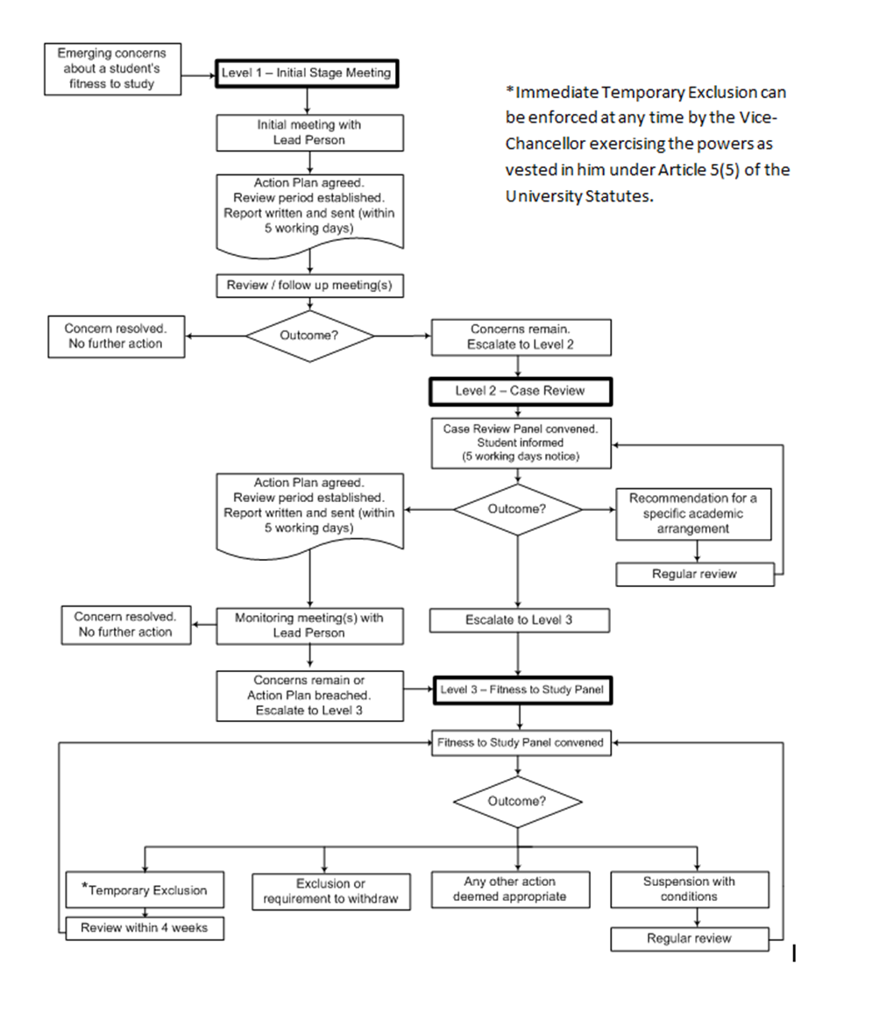

Health, Wellbeing & Fitness for Study Procedure
This procedure is part of the University of Bradford Health, Wellbeing and Fitness for Study Policy.
The procedure is intended to be supportive and:
- Ensure the best interests of the student are being considered in relation to their personal situation, health, mental health or wellbeing.
- Ensure that the student is receiving adequate support.
- Ensure that disability related reasonable adjustments have been considered and where appropriate put in place.
- Enable the student to progress, meet the required learning outcomes and complete their programme.
- Identify a plan of how to progress with clear boundaries and expectations; options may include including continuing their programme with adjustments, suspension of studies for a set period of time or repeating a year of study.
Please refer to University Policy and Procedures on Suspension of Study.
http: / / www.bradford.ac.uk / aqpo / programme-suspension-and-withdrawal /

Structure of the Procedure
The procedure has 3 Levels – 1, 2 and 3. The levels represent the degree of concern and / or the perceived seriousness of the situation.
The procedure can be entered and resolved at any level. In most cases Levels 1 and 2 should be used before escalation to Level 3. If the concerns are not remedied by the recommended and agreed actions at one level the next level may be instigated.
A report of all meetings / Panel meetings and copies of agreed Action Plans should be documented and a copy kept in a suitable, confidential place within the Faculty for the duration of the student’s programme (e.g. personal file).
A copy should be sent to the student and to all other attendees of any meeting no more than 5 working days after the meeting has taken place.

What happens if the student does not attend or engage?
At any stage, if a student is invited but fails to attend a scheduled meeting at any level, contact should be made with the student to ascertain the reason for their absence. If appropriate, another meeting should be arranged. If contact is unsuccessful and / or the student does not attend the re-arranged meeting or engage with the process, the following actions should be taken:
- At Level 1, the lead person should discuss the situation in the student’s absence with their Manager or Head of Programme Area to consider and agree the best course of action.
- At Level 2, the situation will be discussed by the Panel in the student’s absence. If there are straightforward options about how to proceed, agreed expectations, support options and plans should be communicated to the student with a timescale for completion and date of review. If the situation is more complex or unclear, steps should be taken to escalate to Level 3.
- At Level 3, the Panel will consider and agree the best course of action.

Who can instigate the Procedure?
Levels 1 and 2 of the procedure can be instigated by a member of staff with a direct link or primary responsibility for the student’s needs. For example:
- An appropriate member of staff from the student’s Programme Area, such as their Personal Academic Tutor (PAT) or Academic Supervisor, with oversight by the Associate Dean Learning and Teaching.
- A member of staff from the University Disability Service.
Where other members of staff have concerns about a student’s health, wellbeing and behavior they should contact their Manager and / or the Head of their Programme Area who will consider whether this procedure should be implemented.
Level 3 can only be instigated by the Dean of the student’s Faculty or in their absence by their nominee (an appropriate Senior Manager). This decision will be made following consultation with the member(s) of staff raising the concern.

Level 1 – Initial Stage
Level 1 should be used when there are emerging concerns about a student’s health, wellbeing and / or behaviours and the impact this has on their ability to progress on a programme or at University.
Concerns may include (but are not restricted to) a deterioration in health, attitude, personal conduct, attendance, ability to meet deadlines, ability to succeed academically, or ability to participate in student life.
Once concerns have been raised about a student’s fitness for study, an appropriate member of staff should be designated as the ‘lead person’ to instigate Level 1. This would normally be the student’s PAT or Supervisor.
The lead person should contact and / or approach the student, in a sensitive and understanding way, to request a meeting. They should explain that this is as a result of concerns that have been raised about their fitness for study. This could be done in person, by email or letter. The student should be given clear information about the HWFTS procedure, with particular emphasis on the fact that it is designed to be a supportive process.
As Level 1 is intended to be relatively informal, it is recommended that this meeting is on a one to one basis. There may be situations where it is important for others to be present. In such cases the student should be informed.
The student should be made aware of the precise nature of the concern(s) being raised. (Clear examples can be helpful).
- The student should be given the opportunity to give their views on what is happening.
- The member of staff should outline the relevant University boundaries and rules that the student needs to be aware of and remind the student of their personal responsibility (eg to be ‘well enough’ to study and to be respectful of others).
- The member of staff should consider with the student what would be helpful and make the difference to the student in order to support him / her.
- The student should be made aware of any relevant University Support Services such as the Disability or Counselling Service.
Level 1 Initial Meeting:
- An Action Plan should be agreed and drawn up, using the Action Plan pro-forma.
- A review period should be established by agreement, with sufficient time to allow the student to consider the issues and seek support.
It should be made clear to the student at this stage that a continuation of the same or any additional concerns could result in escalation to Level 2 of this procedure.
Level 1 Review / follow up Meetings should include:
- Review of the student’s progress against the Action Plan.
- Explanation / exploration of any further concerns arising.
- Exploration of further / on-going support needed (the member of staff should help the student to access support available to them if necessary).
- Agreement of whether further action is necessary.

Level 1 Review / Follow-up Meeting: Possible Outcomes
- If the concern has been resolved no further action is required. The general expectation is that the student will take personal responsibility and fully engage with the process and with the support recommended.
- If concerns have not been addressed, support has not been accessed and the member of staff feels that progress has not been made, escalation to Level 2 should be considered.

Level 2 – Case Review
Level 2 of the procedure should be used where there is continued and ongoing concern following Level 1, or when there is significant concern about a student’s health, wellbeing, behaviours, safety and / or ability to study, and where a response from the University is required.
A Level 2 Case Review Panel should be convened by the Faculty Administrator and be supported by the Academic Registrar.
The panel should include;
- The Lead Person from Level 1 (If this was not the student’s PAT, then the PAT should be the 4th member of the panel).
- The Dean of the student’s Faculty (Chair).
- A representative from relevant support services (for example a Disability or Mental Health Adviser).
The student should be invited to attend the Level 2 Case Review Panel by the Faculty Administrator in writing. They should be given at least 5 working days’ notice.
The invitation to the meeting should include:
- Date, time and venue of the meeting.
- The purpose of the meeting.
- Whether the student needs to provide any specific documents (e.g. medical evidence).
- A suggestion that the student can be accompanied by someone in a supportive capacity (for example a parent, friend, someone from the University support services or adviser from the Student Advice Centre), but not by someone acting as a legal advocate.
- Disabled students may also be accompanied by a Support Worker e.g. sign language interpreter or Mental Health Worker / Disability Adviser as appropriate to their needs.
- A list of people who will attend the meeting and the reason they will be there.
- A web link to the Health, Wellbeing and Fitness for Study Policy and Procedure.

Level 2 Case Review Panel should include:
- Identification / explanation of the issue / concern (providing clear and specific examples), and any past relevant information.
- An opportunity for the student to give their perspective on the issues and if appropriate a history of events, past experiences and helpful strategies or support for managing these issues.
- Clarification of relevant University expectations and Regulations.
- Clarification of the student’s responsibility at the University (eg to be ‘well enough’ to study and to be respectful of others).
- Consideration of what would be helpful or make the difference to the student in relation to their support and in order to minimise the concerns.
- The student should be made aware of any relevant University Support Services from which they may benefit.

Level 2 Case Review Panel Meeting: Possible Outcomes
- If a student has been referred straight into Level 2, an Action Plan should be agreed with the student detailing any steps the student will need to take and the support to be provided. Regular monitoring meetings should be arranged with the student and a nominated member of staff (normally the Lead Person / PAT).
- If a student has been referred from Level 1 following the Review / Follow-up meeting, a further Action Plan should be agreed detailing any steps the student will need to take and the support to be provided. Regular monitoring meetings should be arranged with the student and a nominated member of staff (normally the Lead Person / PAT).
In either of these cases the student should be made aware of what will happen if the Action Plan is breached, which will normally involve their case moving to Level 3.
At the end of the agreed monitoring period the Lead Person will make the decision as to whether the issue or concern is resolved or whether any further action is required.
If it is not resolved and further action is required, the Lead Person will make a decision regarding the appropriate next stage. This will be one of the options 2 or 3 below.
- A recommendation for a specific academic arrangement which may include a suspension of studies. Such recommendations should be agreed by the student’s.
- Faculty and Programme Area and where appropriate the student.
If suspension of studies is recommended the panel should make sure that both they and the student are fully aware of the implications. Please see relevant extracts from the University Student Suspension Policy at the end of this document* and refer to University Policy and Procedures on Suspension of Study at:
http: / / www.bradford.ac.uk / aqpo / programme-suspension-and-withdrawal /
The student should be given a clear indication of the proposed return date and regular reviews should be built in. In cases where suspension of studies is agreed it must be made clear what needs to happen in order for a return to study to be considered. Responsibilities for arranging meetings and obtaining evidence and documentation must be confirmed and included in the meeting notes.
If the student does not agree the case will move on to Level 3.
- A referral to Level 3 Fitness for Study Panel. This will be appropriate in serious cases for example where there is evidence of a risk to the health and safety of the student or others in the University community. This course of action would be used when it is considered that, temporary exclusion, suspension or withdrawal may be appropriate or if the student has not agreed to a recommendation or Action Plan made under Level 2.

Level 3 – Fitness for Study Panel
Level 3 of the procedure should be used where there is serious or persistent concern about a student’s health, wellbeing and / or behaviours, safety and / or ability to study and cope at university. In most cases escalation to this level will follow attempts to address concerns through Levels 1 and 2. However, in some cases it may be appropriate to proceed directly to Level 3.
A Level 3 Fitness for Study Panel should be convened by the Faculty Administrator and be supported by the Academic Registrar.
The panel should include:
- A DVC or PVC.
- The Dean of the student’s Faculty (Chair).
- The Lead Person from Level 1 (If this is not the PAT they should be included as the 5th member of the panel).
- A representative from relevant support services (for example a Disability or Mental Health Adviser).
Examples of when it may be appropriate to proceed directly to Level 3 might be:
- Where health, wellbeing and ability to study is seriously compromised.
- When all other options to deal with the situations have been explored locally and a wider University perspective is required.
- When a higher level of decision making and authority is required.
- Where there are serious concerns regarding risk to the health and safety of the student and / or where there is a perceived threat and risk to others.
- Where an immediate temporary exclusion is considered to be in the best interests of the student or University.
The decision to convene a Level 3 Fitness for Study Panel will be made by the Dean of the student’s Faculty or in their absence by their nominee (an appropriate Senior Manager). This decision will be made in consultation with the member(s) of staff raising the concern.
The objective of a Level 3 Fitness for Study Panel is to ensure that the University considers all possible options to enable the student to continue with their studies.
The student should be invited to attend the meeting by the Faculty Administrator in writing. They should be given no less than 5 working days’ notice. The invitation to the meeting should include all the information outlined above in Level 2 Procedures.
The student should be encouraged to prepare in advance for the meeting by speaking to key staff, including Student Advice Centre staff. They should obtain any necessary documentation and reports and give consent for disclosure of medical reports. The student may wish to write a short summary report for the meeting.
In preparation for the meeting the key University departments may be invited to write a summary report of the present and past relevant / key issues. The contribution of representatives will be subject to Data Protection legislation and / or professional codes of confidentiality. This information will be sent to the meeting co-ordinator and circulated to people attending the meeting.
It may be helpful to convene the meeting for an initial 30 minutes, before the student arrives. This will allow those who have had no prior involvement with the student / issues to familiarise themselves with the information, the process, and allow them time to understand the issues and the possible options.
The Panel will consider the following:
- A summary of presenting situation, concern(s) being raised, and past relevant information.
- An opportunity for the student to give their perspective of current issues and if appropriate history of events, past experiences and helpful strategies or support for managing the issues.
- Clarification of relevant University expectations and Regulations.
- Clarification of the student’s personal responsibility at University (eg to be ‘well enough’ to study and to be respectful of others).
- Identification of any further information which may be required such as medical evidence.
- Clarification of the options available to the student at this stage e.g. part-time study with support, a period of suspension with repeating, or a recommendation for withdrawal of the student.
- Consideration of what would be helpful or make the difference to the student in relation to the options available.
- The student should be made aware of any relevant University Support Services from which they may benefit.
- Clarification of agreed options / actions and support options that the student is encouraged to access.
- Explicit clarification of the consequences of failing to complete the agreed actions, and / or a continuation of the causes for concern.
- Agreement of any interim monitoring or measures.
- Agreement of a date to meet again to review the situation.
In cases where suspension is the outcome, the meeting should consider and make explicit what is required to happen before the student is permitted to return to study. Please refer to University Policy and Procedures on Suspension of Study.
http: / / www.bradford.ac.uk / aqpo / programme-suspension-and-withdrawal /

Level 3 Fitness for Study Panel: Possible Outcomes
The panel will make a recommendation to the Vice Chancellor.
- A temporary exclusion to allow the student to be assessed by a medical professional, access support services both within and outside of the University or for the University to obtain further information. The exclusion will be reviewed within 4 weeks as set out below in relation to temporary exclusion.
- Suspension with conditions. A student who is suspended from the University may be prohibited from participating in University activities and may either be prohibited from entering the University premises or have restricted rights to enter the premises. The terms of the suspension will be notified to the student in writing, depending on the circumstances of the case. If suspension of studies is recommended the panel should make sure that both they and the student are fully aware of the implications. Please see relevant extracts from the University Student Suspension Policy at the end of this document* and refer to University Policy and Procedures on Suspension of Study at:
http: / / www.bradford.ac.uk / aqpo / programme-suspension-and-withdrawal /
The student should be given a clear indication of the proposed return date and regular reviews should be built in. In cases where a suspension of studies is agreed it must be made clear what needs to happen in order for a return to study to be considered and responsibilities for arranging meetings and obtaining evidence and documentation must be confirmed and included in the meeting notes.
- Exclusion or requirement to withdraw. If the Panel concludes, taking into account the individual circumstances of the case and any supporting medical evidence, that there is no reasonable prospect of the student re-engaging with their programme, a recommendation will be made to the Vice Chancellor that the student is permanently excluded or required to withdraw. This recommendation should only be made in the most serious cases.
- Any other action considered to be appropriate and proportionate.
In cases where withdrawal of the student is the recommendation of the Level 3 Fitness for Study Panel, this must be approved by the Vice Chancellor (or their nominee), who will in turn report this to the next meeting of Senate.

Temporary Exclusion
The Dean of Faculty (or nominee) or the Academic Registrar (or nominee) may refer a case straight to the Vice-Chancellor (or nominee) if it is considered that the risk to the student or the University is very high and an immediate temporary exclusion is the most appropriate course of action.
The Vice-Chancellor may using the powers vested in him under article 5(5) of the statutes impose a temporary exclusion for a set period of time with immediate effect. A student who is subject to a temporary exclusion order is prohibited from entering University premises and from participating in University activities. The exclusion may, exceptionally be subject to qualification, such as the permission to take an examination or to enter the University premises to attend a meeting with a support service such as the Counselling or Disability Service. The terms of a temporary exclusion will be individual to each case and will be notified to the student in writing. A temporary exclusion order does not affect the student’s status as a member of the University.
The decision to exclude will normally be reviewed within four weeks and a Fitness for Study Panel will be convened to consider the case.

Returning to Study
In cases where the outcome of the Health, Wellbeing and Fitness for Study procedures result in a suspension of studies, the procedure for considering a return to study should be made clear to the student at the time of their suspension. Please refer to University Policy and Procedures on Suspension of Study.
http: //www.bradford.ac.uk / academic-quality-unit / policy-and-guidance /
In all cases the student will be asked to provide satisfactory evidence that they have overcome the original difficulties and are well enough to return to study. The precise nature of the evidence required from the student will be dependent on the individual circumstances in each case, but in all cases it is expected that this will involve a report from a recognised independent health professional with sufficient knowledge about the health and wellbeing of the student during the period of suspension, and the potential impact that returning to study might have.
If the student agreed to suspend studies under Level 2 of the procedure, the Case Review Panel that originally considered the matter can make the decision to allow the student to return to study. The decision will be based on the evidence that the student provides and the panel will need to be satisfied that the student is fit to return.
If the decision to suspend or temporarily exclude the student was made at Level 3 of the procedure the decision to allow a student to return to study will be made by the original Fitness for Study Panel concerned.
A suspension should not total more than two years (6 terms or 4 semesters) in any one programme of study.
Where a student returns to study after a temporary exclusion or suspension under this procedure the Panel should also consult other members of support staff regarding arrangements and reasonable adjustments that might be needed to support the student on return.
The Panel’s decision will be communicated in writing to the student prior to their return, and any requirements and arrangements will be made clear. The University will determine the on-going arrangements to support and review of the progress of the student to minimise risk of a recurrence of the original difficulties.

Review and Appeal of Decisions
A student may appeal to a Review and Appeal Panel against a decision reached at Level 2 or Level 3. Students should note that a request for review of a decision will only be accepted if there is evidence of the following:
- That there were demonstrable procedural irregularities in the conduct of the procedures.
- Evidence of prejudice or bias on the part of one or more of the participants in the process.
- Evidence of further material circumstances which could not reasonably have been expected to have been submitted for consideration by the Panel; these might include new, documented medical evidence.
Students should lodge any request for review with the Manager (Complaints and Appeals) by submitting a written statement detailing the grounds for request within 10 working days of being notified of a decision at Level 2 or Level 3. Students should seek advice from the Student Advice Centre.

Membership of the Panel
A Review and Appeal Panel should be chaired by a Deputy or Pro-Vice Chancellor not connected to Level 3 consideration of the student, and also include a lay member of the University Council and a member of the Senate as well as a Students' Union representative. No member of the Panel should have previously been associated with the complaint.
The student should be informed of the date of the Review and Appeal Panel meeting no less than 10 working days in advance. They may choose to appear before the Panel but the Panel may also hear a case, by mutual agreement, in the absence of the student. The student can be accompanied by a friend or representative; however students may not bring legal representation to the meeting without prior consent obtained from the Chair of the Committee which will only be granted in exceptional circumstances. The name of the person attending with the student must be notified to the secretary of the Panel in advance of the meeting.
The Chair of the Panel, in consultation with the Complaints and Appeals Manager, will determine, prior to the meeting, the relevant evidence and documentation required at the meeting and the persons required in attendance at the meeting. The documentation will normally comprise the documentation and papers relevant to earlier consideration during the procedure.
Documentation in support of the request for review should be circulated to the Review and Appeal Panel and to the student no less than five working days before the meeting.
The student, and any accompanying person, will be called to appear before the Panel and the proceedings will continue as follows:
- A statement will be requested from the student about the case;
- Panel will question the student.
A person accompanying the student may be heard by the Panel, subject to the student's approval.
The Panel will then interview in turn:
- The Head of the Programme Area (or appropriate representative).
- Other members of academic or other staff involved in the Heath, Wellbeing and Fitness for Study considerations including the Lead Person.
The Panel should ask the student and the Head of the Programme Area (or representative) concerned to withdraw while it reaches its decision.
The Panel, having considered the evidence will inform the student of its decision and the reasons for that decision. An appeal will be deemed upheld or not upheld. A decision made by the Panel is final and is not open to further appeal under internal University of Bradford procedures. The Review and Appeal Panel will record its deliberations and decisions. In the event that a student’s registration is reinstated the Complaints and Appeals Manager will inform Student Administration Services. In the event that a student is suspended or excluded a recommendation will be made by the Complaints and Appeals Manager to the Vice Chancellor to act under the powers vested in him by statute (Article 5(5)).
The Complaints and Appeals Manager should notify the student in writing, by means of a Completion of Procedures letter, of the Panel’s decision, giving the reasons for it, within five working days of the meeting. Students will be informed of their right to appeal to the Office of the Independent Adjudicator www.oiahe.org.uk .

Monitoring and Reporting:
The Complaints and Appeals Manager will provide the Learning and Teaching Committee with an annual overview report which will present the data by diversity categories.
Extract / information from the University Policy and Procedures on Suspension of Study / Student Suspension standard letters.
In a situation where a student is suspended:
‘Any financial support package they receive (for example, Student Finance England or a University Scholarship / Bursary) will re-calculated and an appropriate reduction made. This may result in repayments to be made or may impact on the amount of any future payment.’
‘If the student is an International student and was issued with a Certificate of Acceptance of Studies (CAS) suspension of studies may have an impact on their Tier 4 Visa.’
‘Students should be made aware that the on-going availability of their programme is not guaranteed and that programmes may change necessitating additional / alternative modules or assessment.’
‘The suspension should take into account the implication of the timing and duration of the suspension for the student’s engagement with the programme and with assessment and re-assessment opportunities.’

